**Kubernetes Deployment and Step-by-Step Guide to Deployment: Update, Rollback, Scale & Delete**

Kubernetes is the mood of the developers right now! It is trending like never before. Kubernetes K8s is an open-source system for managing containerized applications across multiple hosts. It provides basic mechanisms for the deployment, maintenance, and scaling of applications.  Everything in [Kubernetes](https://k21academy.com/docker-kubernetes/kubernetes-for-beginners/) is all about Deployment.

Here is what is going to be covered in this post:

* [What Problems Does Kubernetes Solve?](https://k21academy.com/docker-kubernetes/kubernetes-deployment/#1)
* [What is a Kubernetes Deployment](https://k21academy.com/docker-kubernetes/kubernetes-deployment/#Automated_Rollouts_and_Rollbacks)
* [Kubernetes Deployment Features](https://k21academy.com/docker-kubernetes/kubernetes-deployment/#3)
* [Types of Deployment](https://k21academy.com/docker-kubernetes/kubernetes-deployment/#Rollback)
* [Step-by-step Kubernetes Deployment](https://k21academy.com/docker-kubernetes/kubernetes-deployment/#Ramped)
* [Prerequisites for K8s Deployment](https://k21academy.com/docker-kubernetes/kubernetes-deployment/#K8s_Deployment_Guide)
* [Kubernetes Deployment on a Cluster](https://k21academy.com/docker-kubernetes/kubernetes-deployment/#Deployment_manifest_file)
* [Update a Kubernetes Deployment](https://k21academy.com/docker-kubernetes/kubernetes-deployment/#update)
* [Rollback Kubernetes Deployment](https://k21academy.com/docker-kubernetes/kubernetes-deployment/#3_Display_the_deployment)
* [Scale-Up of a Kubernetes Deployment](https://k21academy.com/docker-kubernetes/kubernetes-deployment/#Scale-up)
* [Scale-Down of a Kubernetes Deployment](https://k21academy.com/docker-kubernetes/kubernetes-deployment/#scale-down)
* [Delete the Kubernetes Deployment](https://k21academy.com/docker-kubernetes/kubernetes-deployment/#kubectl_get_po_l_app_nginx_app)
* [Kubernetes Deployment: Tinder’s Move to Kubernetes](https://k21academy.com/docker-kubernetes/kubernetes-deployment/#kubectl_get_po_l_app_nginx_app)

Since the whole idea of Kubernetes is based on containers and their management of it, it eases the monitoring tasks. Kubernetes orchestrates the [networking](https://k21academy.com/docker-kubernetes/kubernetes-networking/), computing, and [storage infrastructure](https://k21academy.com/docker-kubernetes/kubernetes-persistent-storage-pv-pvc-and-storage-class/). It gets rid of the need for manual orchestration in a cluster and automates the orchestration process so that the applications are highly available and makes sure that the resources are optimally utilized. K8s prominently helps in solving the issues below:

* Load balancing
* Horizontal Scaling
* Self-Healing
* Automated Rollouts and Rollbacks
* Secret and Configuration Management
* Storage Orchestration

**What is a Kubernetes Deployment**

As said earlier everything about Kubernetes is all about Deployment! Deployment is a type of Kubernetes object that describes the desired state of our system and how we want our deployments to occur. In other words, it is like any other controller such as Replication Controller and Replica Set.

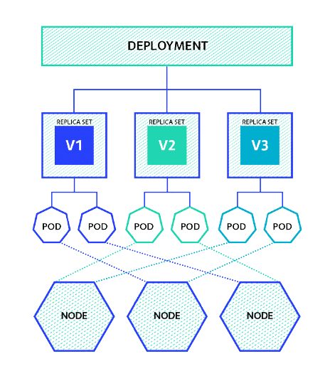

Deployments on a high level are all about updates and rollbacks. The deployment controller provides declarative updates for pods and replica sets. These updates include things such as updating the version inside the spec file, increasing, or decreasing the number of pod replicas. A deployment manifest file includes the pod definition, the number of replicas and can include the preferred deployment strategy.  Moreover, you don’t need individual spec files, one manifest file is enough to manage all these.

**K8s Deployment Features**

A Deployment owns and manages one or more ReplicaSets. And Replica Set manages the basic units in Kubernetes – Pods.



Relationship among Pods, ReplicaSet and Deployment

There a few more important features of a Kubernetes Deployment that one needs to know for the best utilization.

* **Multiple Replicas:**Multiple replicas of pods are created for high availability and load balancing with the help of deployment. By default, one count of Replicas is created by K8s, even if you don’t specify it. Thus, it makes sure that the required number of instances are running all the time and the new pod will be spun up in no time.
* **Upgrade:**The major benefit of using Deployment to control your pods is the ability to perform rolling updates. The rolling update allows you to update the configuration of the pods gradually, and Deployments offer numerous options to control this process.
* **Rollback:** Rollback Deployment is going back to the previous instance of the deployment if there is some issue with the current or new deployment.
* **Scaling:**The number of pods running should be dependent on the traffic. For this purpose, scale up and scale down strategies are defined in the deployment manifest.

**Types of Kubernetes Deployment**

In Kubernetes there are a few different ways to release an application, it is necessary to choose the right strategy. Also, the right deployment procedure depends on the needs, we have mentioned some of the possible strategies below:

* **Recreate:** This method terminates the old version and releases the new one.
* **Ramped:** This technique releases a new version in a rolling update one after the other.
* **Blue/green:** This is where a new version is released alongside the old version then switch traffic.
* **Canary:** This is procedure releases a new version to a subset of users, then proceeds to a full rollout.

**K8s Deployment Guide**

Before we hop on to a simple pod deployment, there are some prerequisites that have that are necessary. Do have a look at them and check out the note if you need help with them.

**Prerequisites for K8s Deployment**

* [Docker](https://k21academy.com/docker-kubernetes/docker-architecture-docker-engine-components-container-lifecycle/) has to be installed on master and worker nodes as well
* Kubernetes Cluster should be set up at least with one worker node
* Deployment manifest file

**Kubernetes Deployment on a Cluster**

1. Writing a deployment manifest YAML file.

$ vi nginx-deploy.yml

#Deployment

#nginx-dploy.yml

apiVersion: apps/v1

kind: Deployment

metadata:

name: nginx-deploy

labels:

app: nginx-app

spec:

replicas: 3

selector:

matchLabels:

app: nginx-app

template:

metadata:

labels:

app: nginx-app

spec:

containers:

- name: nginx-container

image: nginx:1.7.9

ports:

- containerPort: 80

1. Create a deployment from the nginx-deploy.yml that we just wrote.

$ kubectl create -f nginx-deploy.yml

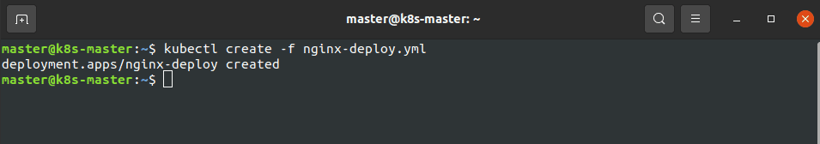

1. Check if replicas are running successfully.

$ kubectl get deploy -l app=nginx-app

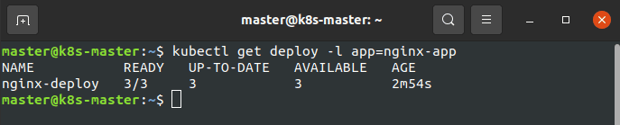

1. Check the ReplicaSets of our deployment.

$ kubectl get rs -l app=nginx-app

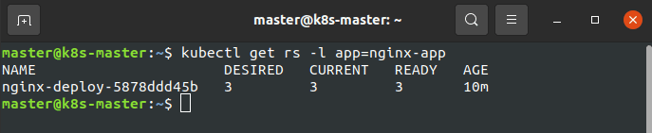

1. Display the pods which are a part of this deployment.

$ kubectl get po -l app=nginx-app

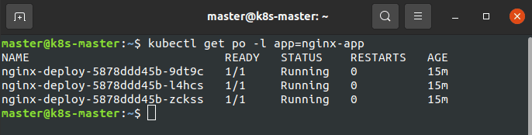

1. Check complete details of the deployment that we just created.

$ kubectl describe deploy nginx-deploy

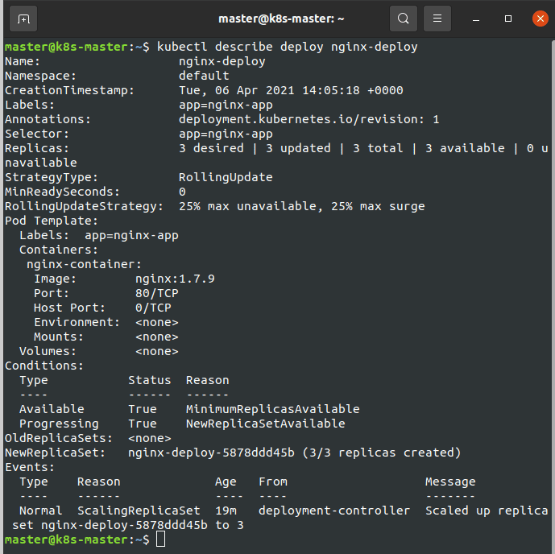

**Update a Kubernetes Deployment**

1)Update the image of the current deployment to 1.9.1

$ kubectl set image deploy nginx-deploy nginx-container=nginx:1.9.1

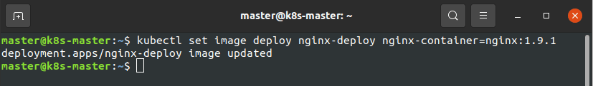2) Check the status of the deployment

$ kubectl rollout status deployment/nginx-deploy

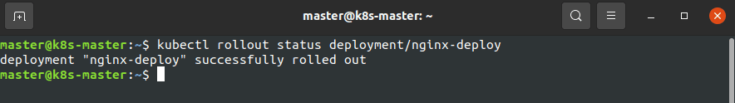3) Display the deployment

$ kubectl get deploy

**Rollback Kubernetes Deployment**

1) Current deployment image accidentally updated to v1.91, which is invalid.

$ kubectl set image deploy nginx-deploy nginx-container=nginx:1.91 --record

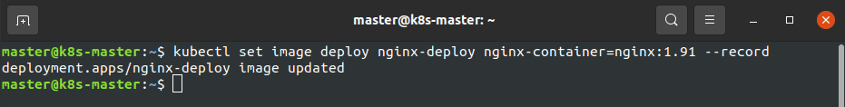

2) Since the output of the update command is misleading, we have to check the status of the deployment

$ kubectl rollout status deployment/nginx-deploy

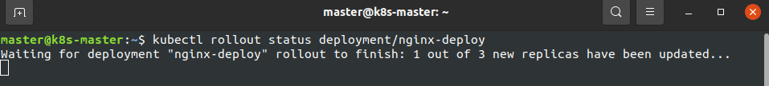3) Since we had applied ‘–record’ the commands executed before will be recorded.

$ kubectl rollout history deployment/nginx-deploy

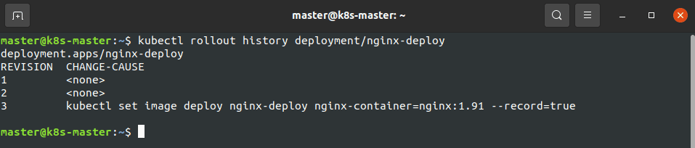

4) To fix this issue, we have to undo the last update.

$ kubectl rollout undo deployment/nginx-deploy

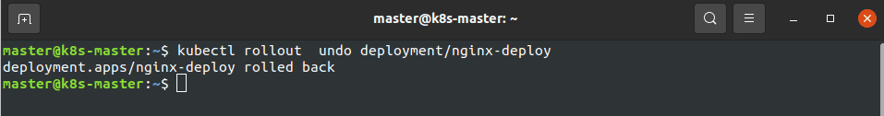5) Check the status of the deployment

$ kubectl rollout status deployment/nginx-deploy

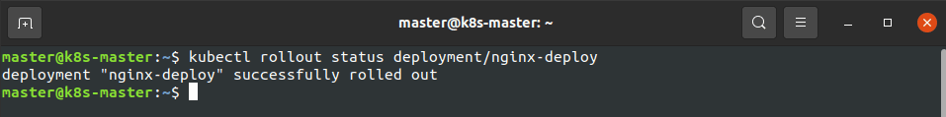

**Scale-Up of a Kubernetes Deployment**

Imagine there is a heavy load on your website which leads to traffic and you want to update the number of application instances, you can follow the procedure below in order to do so.

1) Scale-up the app instances from 3 to 5

$ kubectl scale deployment nginx-deploy –replicas=5

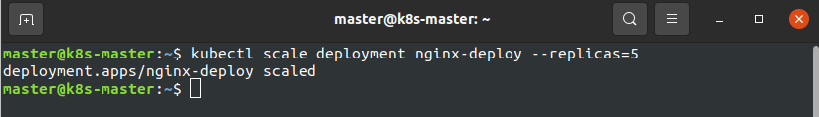2) Display the instances

$ kubectl get deploy

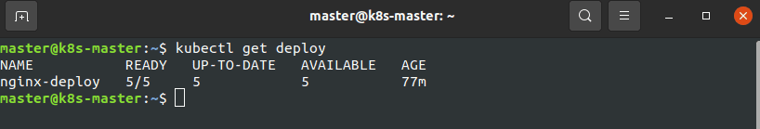3) Check the pods

$ kubectl get pod

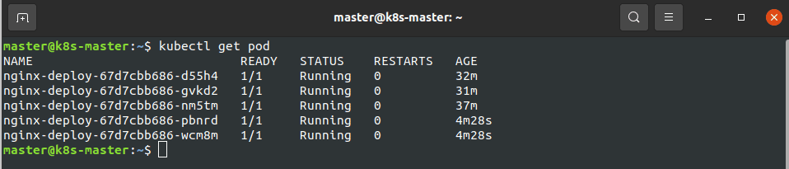

**Scale-Down of a Kubernetes Deployment**

If there is less load on your website which leads to resource wastage and you want to update the number of application instances, you can follow the procedure below in order to do so.

1) Scale down the app instances from 5 to 1

$ kubectl scale deployment nginx-deploy –replicas=1

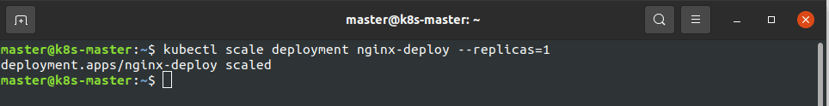2) Display the instances

$ kubectl get deploy

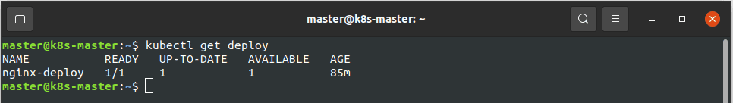

3) To view all the pods which are a part of the nginx-deployment

$ kubectl get po -l app=nginx-app

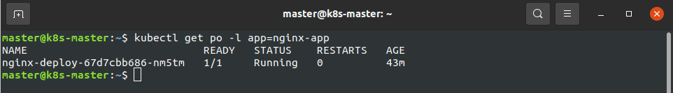

**Delete the Kubernetes Deployment**

1) Delete all the resources like pods, deployments, ReplicaSets

$ kubectl delete -f nginx-deploy.yml

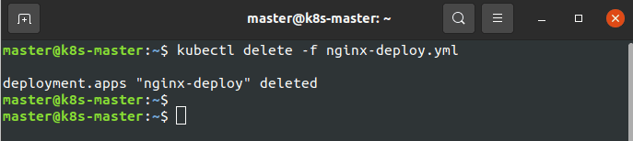

2) To make sure everything is erased.

$ kubectl get po -l app=nginx-app

